Name of Teaching Staff | Mr.Sachin Jagannath Pukale |  | 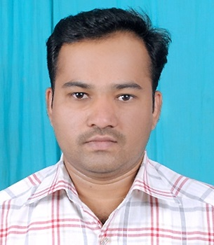
Designation | Lecturer
Department | Information Technology
Date Of Joining The Institution | 05/10/1987
Qualification with Class  /Grade | UG | PG | Ph.D
Qualification with Class  /Grade | B.E. 1st  Class | M.E. 1st  Class | Nil
Total Experience In Years | Teaching | Industry | Research
Total Experience In Years | 10 | 02 | Nil
Papers Published | National: 02 |  | International: Nil
Papers Presented In Conference | National: 02 |  | International: Nil
Ph.D.? Give Field And University | Field |  | University
Ph.D.? Give Field And University | Nil |  | Nil
Ph.Ds/ Projects Guided | Ph.D |  | Projects At Masters Level
Ph.Ds/ Projects Guided | Nil |  | Nil
Books Published/IPRS/Patents | Nil
Professional Membership | Life Member of ISTE (LM-23790) FIE (India) (F-124331-0),  F.I.E.T.E .(India) (F-198754), Member of N.U.T.A (4378)
Consultancy Activities | Hony. Secretary of IETE Nagpur Local Centre Nagpur From June 2010 To June 2012& June 2018 to June 2020
Awards
Grants Fetched
Interaction With Professional Institution | Delivered Guest Lectures, Attended STTPs, FDPs, Seminars &  Workshops of Various Professional Institutions, Passed 06 NPTEL Courses
Biodata in AICTE format

Name & Signature of Staff

Mr.Sachin Jagannath Pukale

